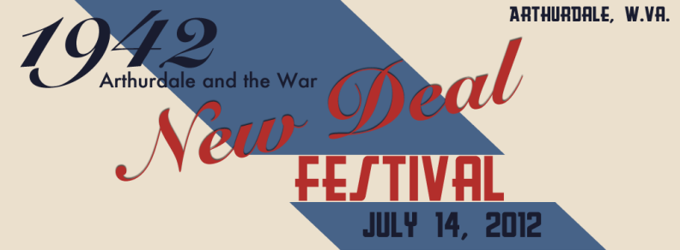
Arthurdale Heritage, Inc.
PO Box 850 Arthurdale, WV 26520

304 864-3959
email:ahi@arthurdaleheritage.org

This year’s New Deal Festival theme is 1942 Arthurdale and the War. We will have a military encampment of WWII reenactors plus Eleanor & Franklin. We are working on the ad booklet.

You can place an “In honor of” or “In memory of” a loved one or homestead family. (We can design it – send us a rough idea plus a picture, if you wish. Or sketch it on enclosed sample sheet.)

Large Ad Pricing
$50 Quarter page ad | $150 Three-quarter page ad
$100 Half page ad | $200 Full page ad

_____ YES, I want to place a larger “In memory of” or an “In honor of” ad for a loved one or homesteader family. (see sample sheet for sizes)

We also offer a listing of Booster names for $10.

Examples:
John & Betty Smith
Betty Smith - In memory of David Smith
_____ YES, I want to be a festival booster for $10 per listing and I have printed the names below or on the back of this sheet.
$10 Booster ad(s): _______________________________________________________
____________________________________________________________________
____________________________________________________________________
Please complete and return the form below by May 25.
We appreciate your support!

Please make check payable to Arthurdale Heritage, Inc.
and mail to PO Box 850, Arthurdale, WV 26520

